digital lab report

Project title: Smart Parking Management System
Submitted by: Team 21
Team Members:
Garvit Pant: 24BCE10593
Aditri Sharma: 24BCE10919
Yoshita Purohit: 24BCE11075
Drishti Agarwal: 24BCE10821
Devang Srivastava: 24BCE10124



Submitted to: Prof. Priscilla Dinkar Moyya
Slot:C11+C12
Class no: BL2025260500380

REPORT 2
1. Introduction:
The Smart Parking Management System is a Java-based desktop application developed using Java Swing to efficiently manage parking operations.
In modern urban environments, managing parking spaces manually can lead to inefficiencies, confusion, and data loss. This system provides a digital solution that automates vehicle entry, exit, slot allocation, and billing.
The application ensures:
- Real-time tracking of parking slots
- Automated fee calculation
- Persistent data storage using serialization

2. Objectives of the Project:
The main objectives of the Smart Parking Management System are:
- To develop a GUI-based parking system using Java Swing
- To implement efficient parking slot allocation
- To automate billing based on time and vehicle type
- To ensure data persistence using file handling
- To apply advanced Java concepts in a real-world system
- To generate reports and maintain parking history

3. Methodology:
The system follows a modular approach:
1. User Interaction (GUI)
- User enters vehicle details through forms
- GUI built using Swing components
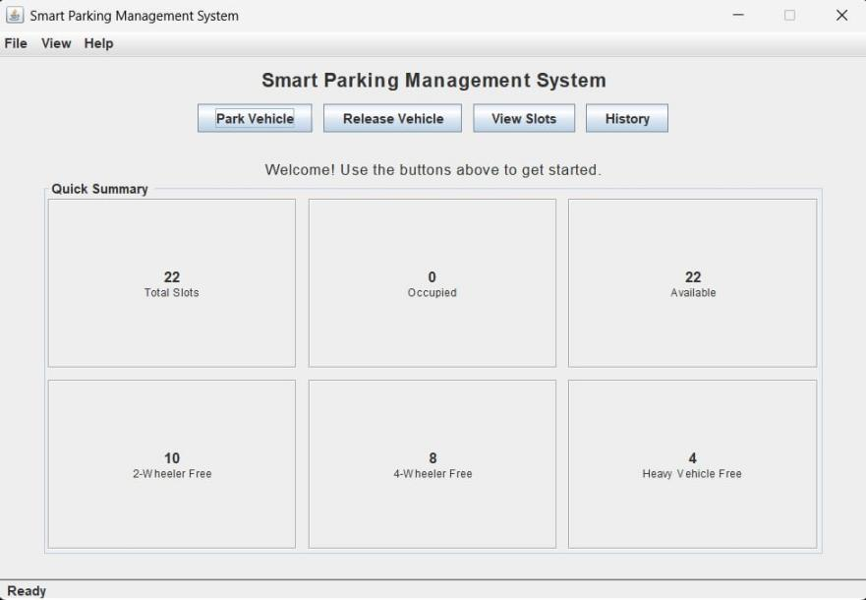
Figure 1: Main Dashboard of the System
2. Parking Allocation
- System checks available slots
- Assigns appropriate slot based on vehicle type
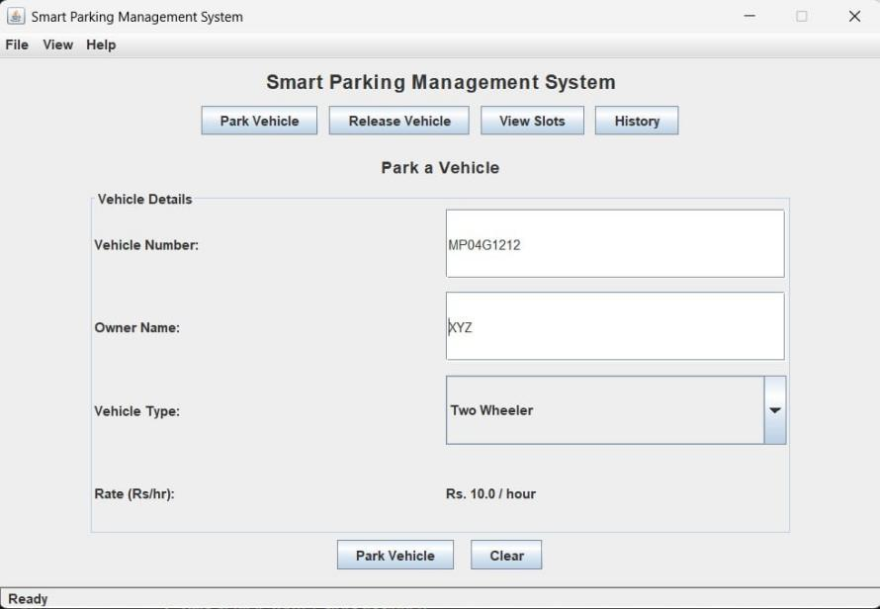
Figure 2: Park Vehicle interface

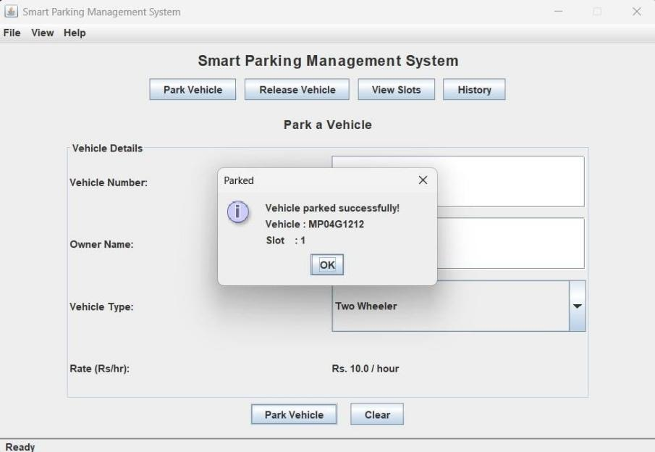
Figure 3: Parking Slot Allotment

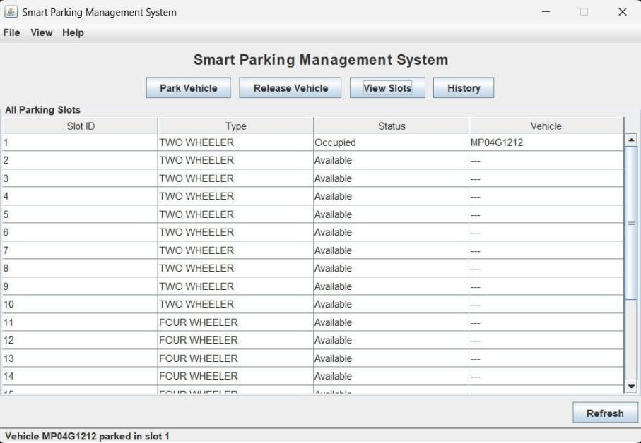
Figure 4: Parking Slots View

3. Vehicle Exit & Billing
• Calculates duration

• Generates parking fee automatically

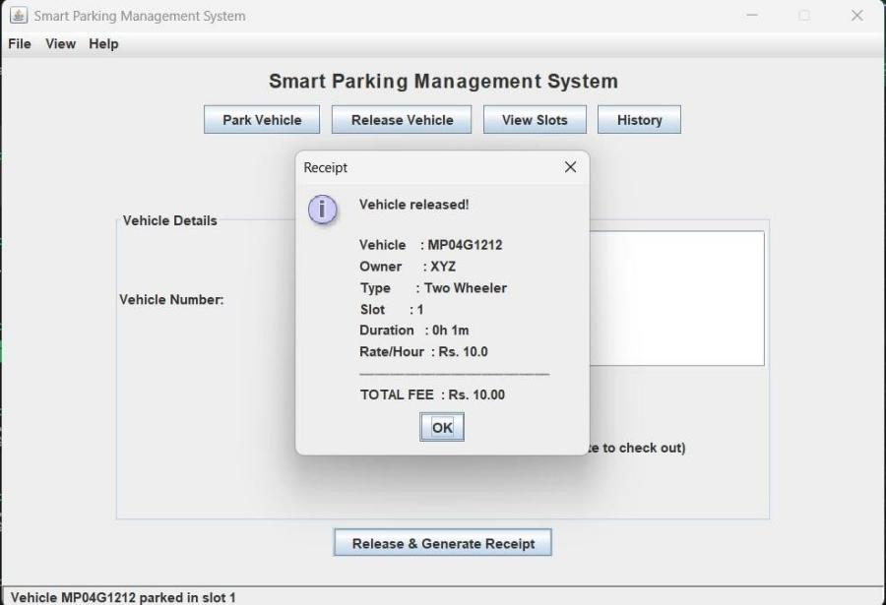
Figure 5: Fee Receipt Screen
4. Data Storage
• Data stored using serialization

• Auto-save runs every 60 seconds using a background thread

5. History & Reports
• Stores past records

• Allows export to .txt file

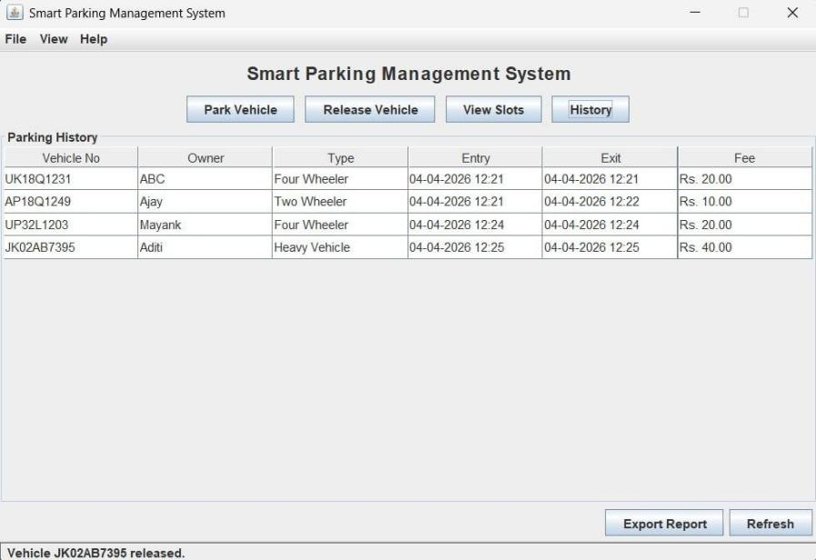
Figure 6: Parking history table

4. Outcomes of the Project:
After completing this project, the following outcomes were achieved:
- Successfully developed a fully functional parking management system with GUI
- Enabled efficient parking slot allocation and release system
- Implemented automatic fee calculation based on vehicle type and duration
- Achieved data persistence using file handling and serialization
- Integrated multithreading to perform background auto-save operations
- Created a modular and scalable code structure using OOP principles
- Improved understanding of real-world application development using Java • Enhanced skills in GUI design, debugging, and exception handling

5. Advanced Java Concepts Used:
The project demonstrates the application of several advanced Java concepts:

Object-Oriented Programming (OOP)
• Use of classes, objects, encapsulation, and abstraction • Implemented in:
o Vehicle.java o ParkingSlot.java o Parkable.java

Interfaces
- Parkable.java defines behavior for parkable entities
- Promotes abstraction and flexibility
Inheritance
- Vehicle class implements the Parkable interface

Enumerations (Enums)
• Used for defining constant values:
o VehicleType o SlotType o ErrorCode

Exception Handling
- Custom exception: ParkingException.java
- Used with try-catch blocks for robust error handling

Multithreading
- Implemented using AutoSaveThread.java
- Background thread automatically saves data every 60 seconds
- Uses daemon threads

File Handling & Serialization
- Implemented in FileManager.java • Uses:
o ObjectOutputStream o ObjectInputStream
- Ensures persistent storage of parking data

Collections Framework
• Data structures used: o HashMap o LinkedHashMap o List

• Managed in ParkingService.java Stream API & Lambda Expressions
• Used for:
o Filtering parking records o Mapping and processing data efficiently

JavaBeans
- Getter and Setter methods used across model classes
- Ensures proper encapsulation Java Swing (GUI Development)
- Used to build the user interface:
o JFrame, JPanel, JTable o JComboBox, JMenuBar, JOptionPane

Layout Managers
• Used for organizing GUI components:
o BorderLayout o GridLayout o FlowLayout o CardLayout

6. Conclusion:

The Smart Parking Management System successfully demonstrates how advanced Java concepts can be applied to build a practical, real-world application. The project not only improves programming skills but also provides insights into software design, user interaction, and system efficiency.

